To get the API response key for the RazorPay from the PostMan

Now search for Public API and in that search for Razor Pay and then obtain the API key 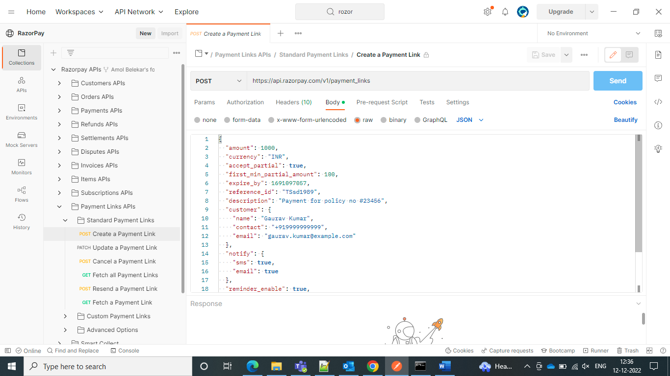

And then go for the changing of the name and email and contact and test this API.

Done with the postman and now go for the Pega and create one rest integration in that give the API key from the razorpay credentials.

You can go to razorpay website and then go to the settings and then go for the API creation generation. You will be given with one test API key

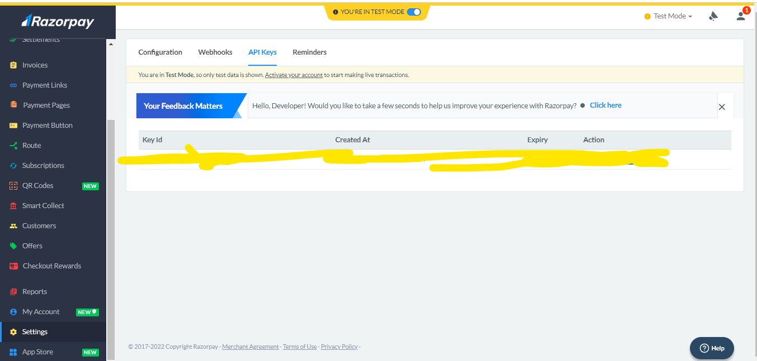and then now create the data page and then paste the key and password In your integration setup wizard page

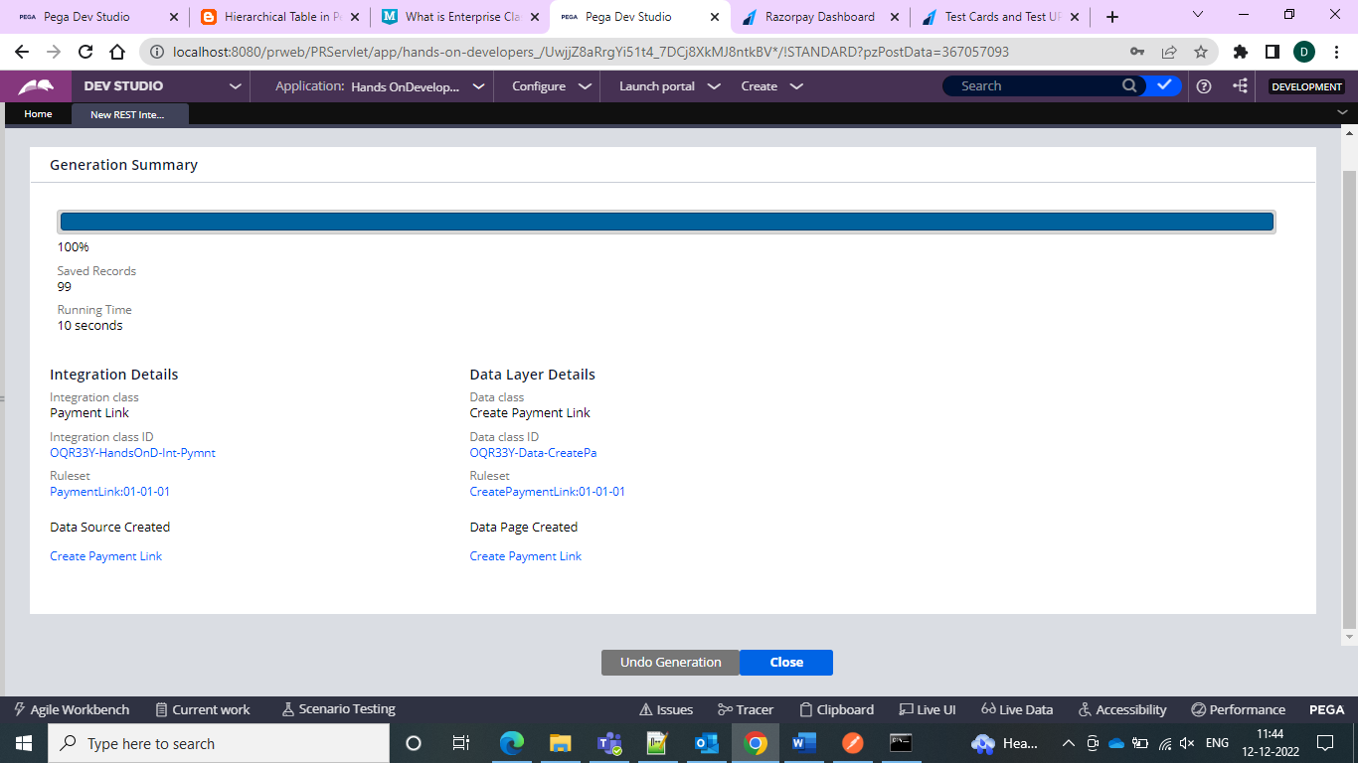

And then give the D_Page with your required parameters and then give the same params in the request DT

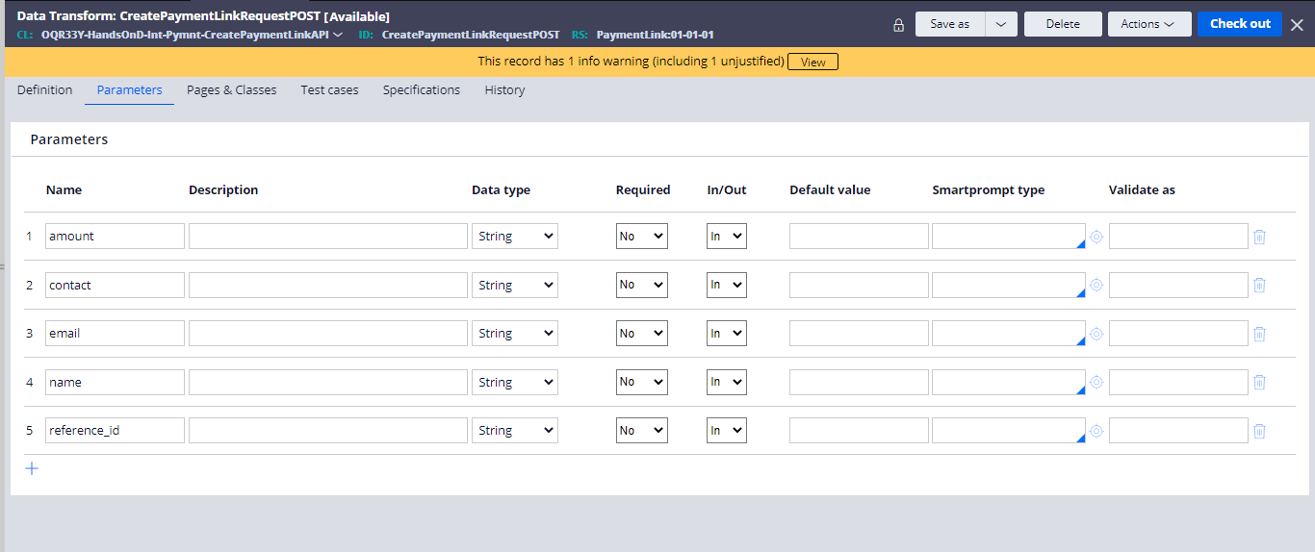

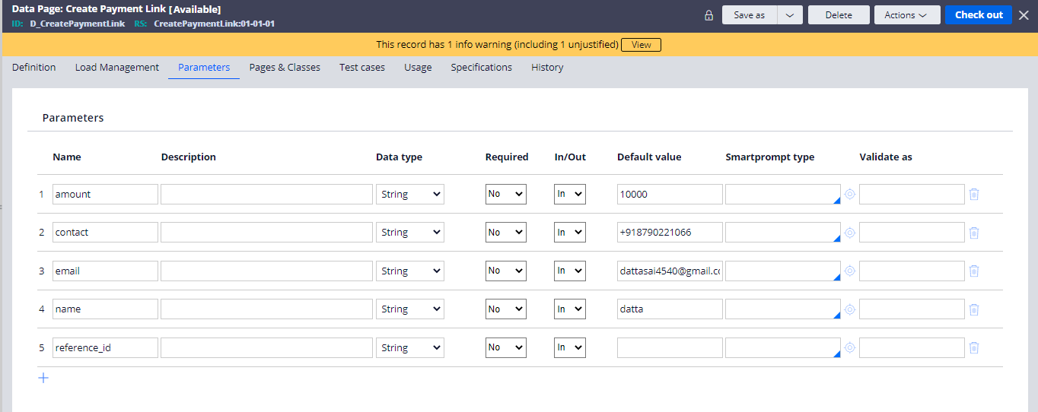

And then modify the steps of the update page with the params instead of the hardcoded values

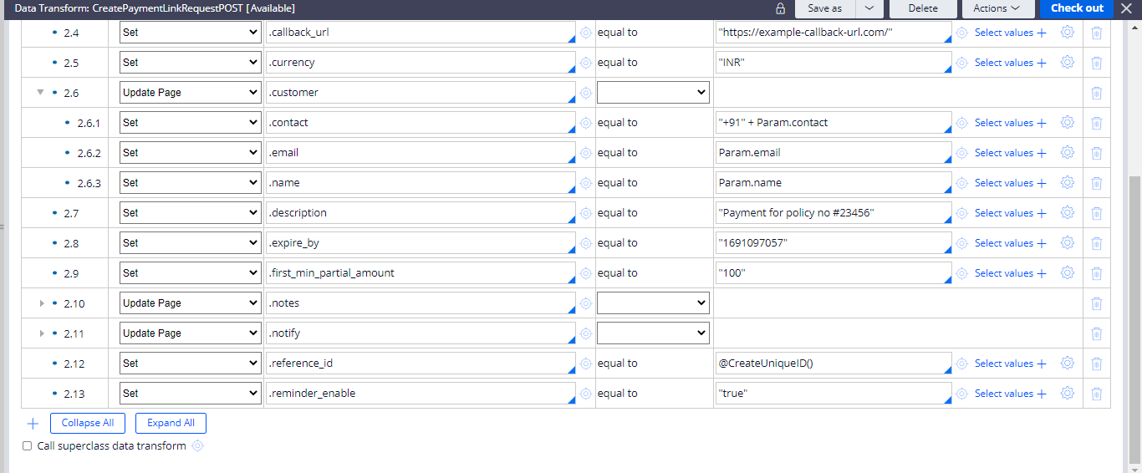

And set the accept partial as false and BOOM you are done with the setup.

Now simply run the D_Page and give the required parameters

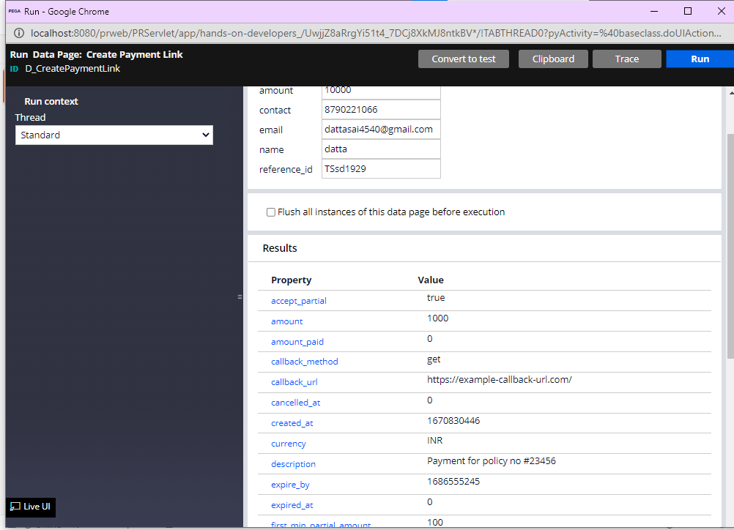

And you would receive the email with this link

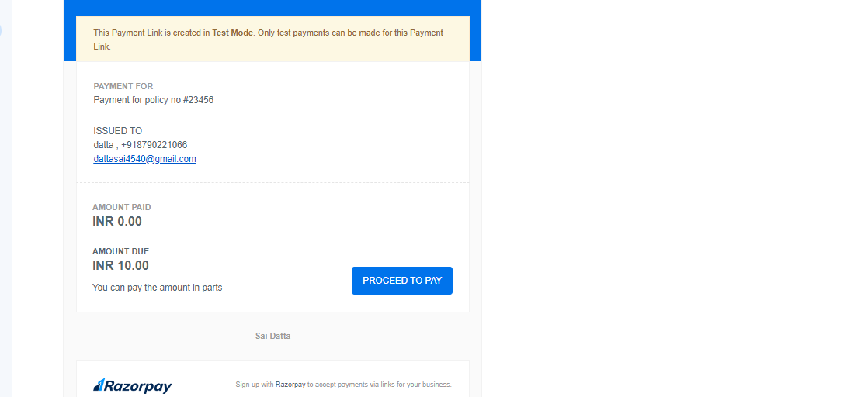

And hence the Payment link would redirect and can start paying.

Hence this is the rest integration.